**A Project Report**

**On**

**Online Doctor Appointment System & Meds Delivery**

Submitted in partial fulfilment of the requirements for the award of degree of

**Bachelor of Computer Application (Science)**

**Submitted By:**

**21 Hariom Annasaheb Tarakh**

Academic Year: 2023– 2024

**Submitted to:**

**Savitribai Phule Pune University**



Shree Chanakya Education Society

**Indira College of Commerce and Science, Pune**

**Vice Principal & (H.O.D) Guided By**

**Prof. Shivendu Bhushan Prof. Divya Chitre**

**Index**

|  |  |  |  |
| --- | --- | --- | --- |
| Sr. No |  | Particulars | Page No. |
| 1 |  | Abstract |  |
| 2 |  | Introduction |  |
|  | 2.1 | Motivation |  |
|  | 2.2 | Problem statement |  |
|  | 2.3 | Purpose/Objectives/goals |  |
|  | 2.4 | Literature survey |  |
|  | 2.5 | Project Scope and Limitations |  |
| 3 |  | System Analysis |  |
|  | 3.1 | Existing System |  |
|  | 3.2 | Scope and Limitation of existing system |  |
|  | 3.3 | Project perspective, features, stakeholders |  |
|  | 3.4 | Requirement Analysis |  |
|  | 3.4.1 | Functional Analysis |  |
|  | 3.4.2 | Performance Analysis |  |
|  | 3.4.3 | Security Analysis |  |
| 4 |  | System Design |  |
|  | 4.1 | Design constraints |  |
|  | 4.2 | System Model |  |
|  | 4.2.1 | Data Flow Diagram |  |
|  | 4.2.2 | Data Model |  |
|  | 4.3 | User Interface |  |
| 5 |  | Implementation Details |  |
|  | 5.1 | Software and hardware specifications |  |
| 6 |  | Output and Report Testing |  |
|  | 6.1 | Test Plan |  |
|  | 6.2 | Black Box Testing/Data validations Test cases |  |
|  | 6.3 | White Box Testing/functional validations Test cases and results |  |
| 7 |  | Conclusion and Recommendation |  |
| 8 |  | Future Scope |  |
| 9 |  | Bibliography and References |  |

**Acknowledgement**

We would like to express our sincere and heartfelt gratitude to our institution” Indira College of Commerce and Science” which provided us with excellent opportunity to achieve our most cherished goal in life to become bachelors degree in BCA Science.

We are extremely grateful to our respected Vice Principal and HOD Prof, Shivendu Bhushan for providing excellent academic environment which has made this endeavour possible.

We take this opportunity to express our deep sense of gratitude to our guide Prof. Divya Chitre for their resplendent idea and constant encouragement in making this project unmitigated success. Their thoughtfulness and understanding were vast and thoroughly helpful in successful completion of project. Our sincere thanks to all our faculties and non-teaching staff for their at most co-operation.

Finally we proudly thank our parents and friends for their constant support and priceless guidance in throughout this endeavour.

Hariom Annasaheb Tarakh

1. **Abstract:**

The doctor appointment system is an online platform aimed at bridging the gap between doctors and patients by providing a convenient and efficient way to schedule appointments, consult doctors, and purchase medicines. This system enhances accessibility to healthcare services, improves patient-doctor communication, and streamlines the appointment booking process. Patients can easily search for doctors based on their specialization, view available time slots, and book appointments accordingly. Additionally, patients can also purchase medicines prescribed by their doctors through the platform. On the other hand, doctors can register on the platform, manage their appointments, and view their daily schedules.

**2. Introduction:**

**2.1 Motivation:**

The motivation behind developing the doctor appointment system stems from the need to overcome the challenges faced in traditional appointment booking processes. Traditional methods often involve long waiting times, manual paperwork, and difficulty in finding suitable doctors. This online platform aims to address these issues by providing a user-friendly interface for both doctors and patients, thereby enhancing the overall healthcare experience.

**2.2 Problem Statement:**

The traditional appointment booking system is often plagued by inefficiencies such as long waiting times, difficulty in finding suitable doctors, and lack of transparency in appointment schedules. Additionally, patients may face challenges in purchasing prescribed medicines. The doctor appointment system aims to address these issues by providing an efficient and transparent platform for appointment scheduling and medicine purchase.

**2.3 Purpose/Objectives/Goals:**

• To provide a user-friendly platform for patients to easily search for doctors based on specialization, location, and availability.

• To streamline the appointment booking process by allowing patients to book appointments online at their convenience.

• To facilitate seamless communication between doctors and patients through the platform.

• To enable patients to purchase prescribed medicines online, thus improving accessibility to healthcare resources.

• To provide doctors with a convenient way to manage their appointments and view their daily schedules.

**2.4 Literature Survey:**

A comprehensive literature survey was conducted to understand the existing systems and platforms related to doctor appointment scheduling and online medicine purchase. Various research papers, articles, and case studies were reviewed to identify the key features, functionalities, and best practices in this domain. The insights gained from the literature survey informed the design and development of the doctor appointment system.

**2.5 Project Scope and Limitations:**

**Scope:**

• The doctor appointment system allows patients to search for doctors based on various criteria such as specialization, location, and availability.

• Patients can book appointments with their preferred doctors and view their appointment schedules.

• The system enables patients to purchase prescribed medicines online.

• Doctors can register on the platform, manage their appointments, and view their daily schedules.

**Limitations**:

• The system's functionality may be limited by the availability of doctors and their willingness to participate in the platform.

• The accuracy of the appointment schedules and medicine availability may depend on real-time updates from doctors and pharmacies.

• The system may face challenges related to data privacy and security, particularly concerning patient information and medical records.

• Access to the platform may be restricted by factors such as internet connectivity and device compatibility.

**3. System Analysis:**

**3.1 Existing System:**

The existing system for doctor appointment may involve manual processes such as phone calls or physical visits to book appointments with doctors. Patients may need to navigate through various phone lines or visit clinics/hospitals to schedule appointments, which can be time-consuming and inefficient. Additionally, there may be limited options for searching and selecting doctors, leading to difficulties in finding suitable healthcare providers.

**3.2 Scope and Limitation of Existing System:**

Scope: The existing system allows patients to book appointments with doctors using traditional methods such as phone calls or in-person visits.

Limitations: Limited accessibility: Patients may face challenges in accessing healthcare services, especially in remote areas.

Time-consuming process: Booking appointments through traditional methods can be time-consuming and inconvenient for patients.

Limited options: Patients may have limited options for selecting doctors, leading to difficulty in finding suitable healthcare providers.

• Lack of transparency: The existing system may lack transparency in appointment schedules, leading to uncertainty for patients.

**3.3 Project Perspective, Features, Stakeholders:**

• Project Perspective: The doctor appointment system aims to streamline the appointment booking process by providing an online platform where patients can easily search for doctors, book appointments, and purchase medicines.

• Features:

• Doctor search: Patients can search for doctors based on specialization, location, and availability.

• Appointment booking: Patients can book appointments with their preferred doctors online.

• Medicine purchase: Patients can purchase prescribed medicines through the platform.

• Doctor registration: Doctors can register on the platform, manage their appointments, and view their daily schedules.

• Stakeholders:

• Patients: Users who require healthcare services and want to book appointments with doctors.

• Doctors: Healthcare providers who offer their services through the platform.

• Pharmacists: Providers of medicines who may collaborate with the platform for medicine sales.

• Administrators: Individuals responsible for managing and maintaining the platform.

**3.4 Requirement Analysis:**

**3.4.1 Functional Analysis:**

Identifying the functional requirements of the doctor appointment system, including features such as doctor search, appointment booking, and medicine purchase.

**3.4.2 Performance Analysis :**

Evaluating the performance requirements of the system, such as response time, scalability, and reliability, to ensure optimal performance under varying conditions.

**3.4.3 Security Analysis :**

Assessing the security requirements of the system to safeguard patient information, secure transactions, and prevent unauthorized access to sensitive data.

**4) System Design:**

**A) ERD**

**4.2.1) Data Flow Diagram:**

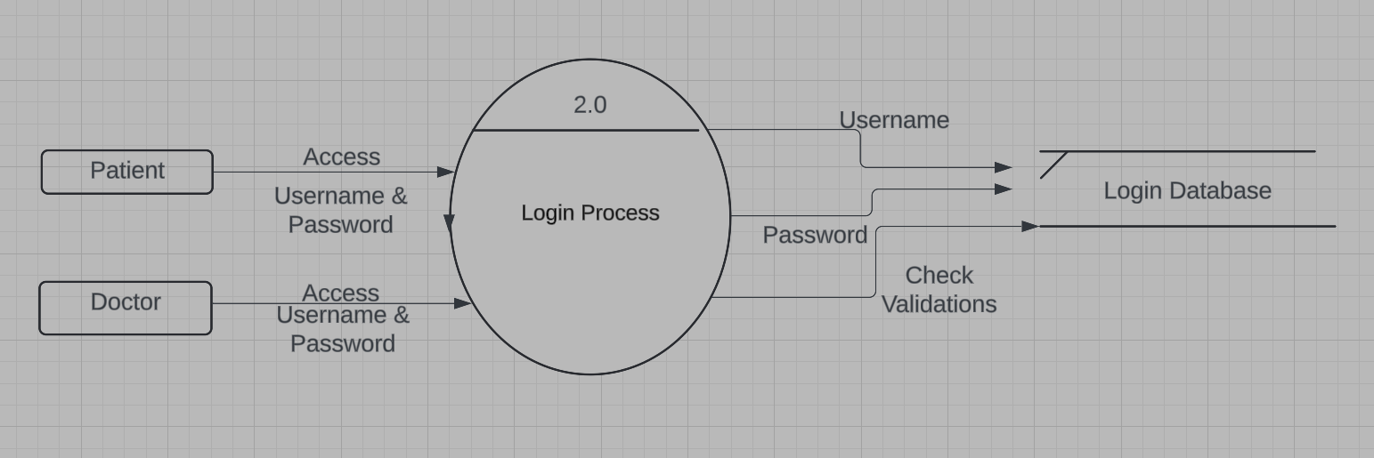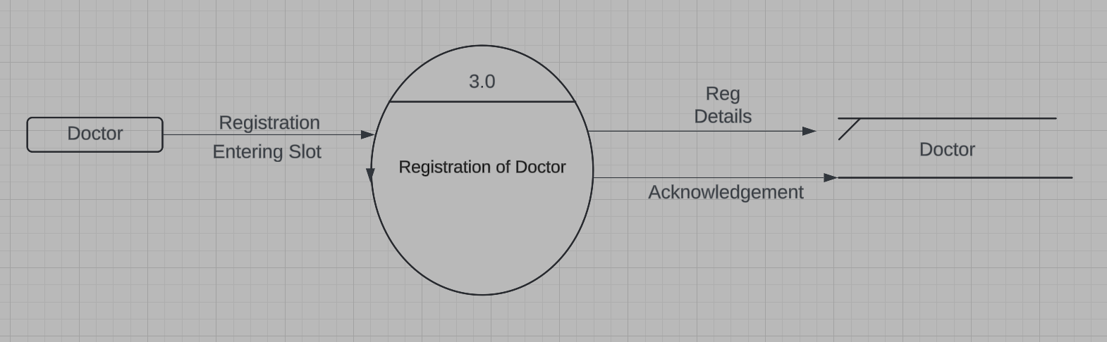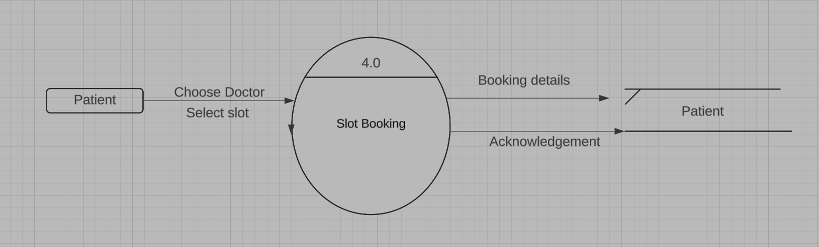

**4.2.2) Data Model:**

**A) Class Diagram:**

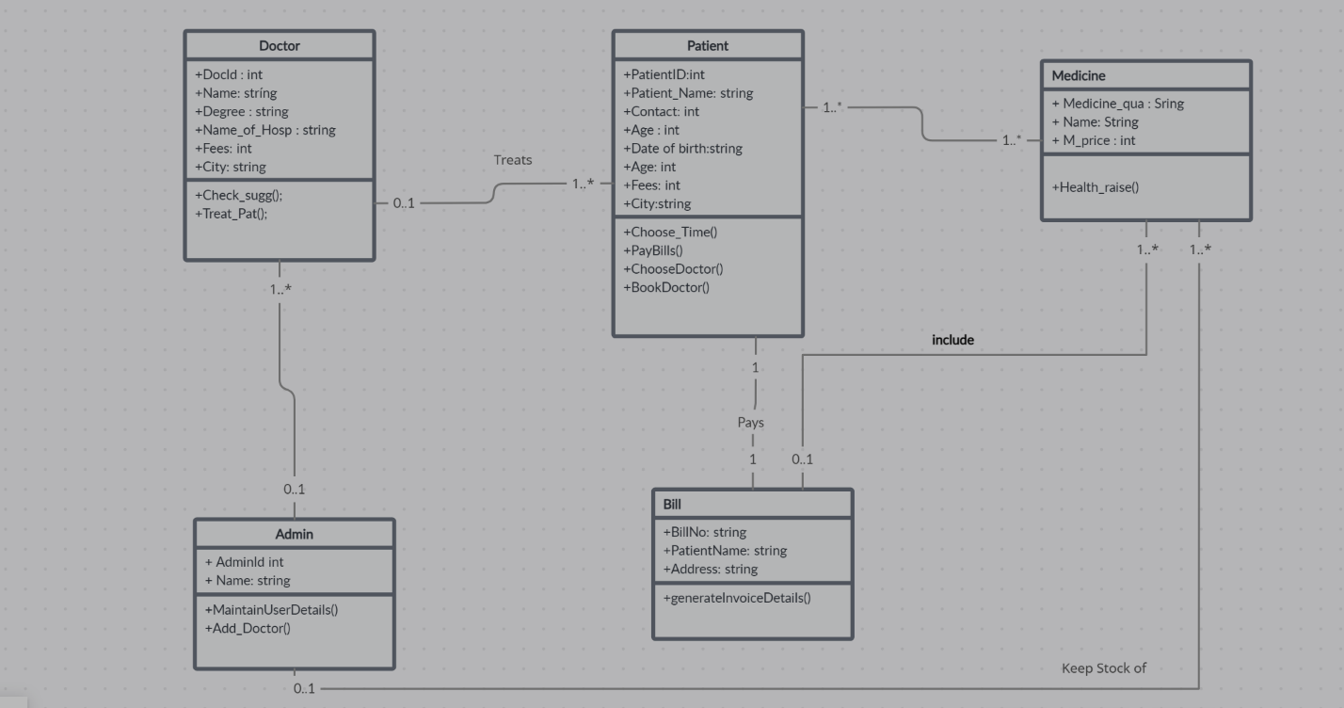

**C) Use Case Diagram:**

**D) Activity Diagram:**

**

**F) Component Diagram:**

**G) State Diagram:**

**H) Sequence Diagram:**

**4.3) User Interface:**

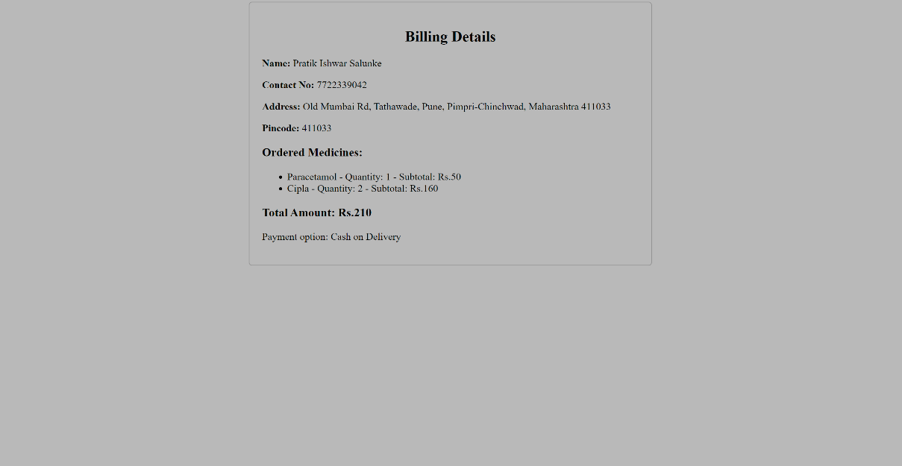

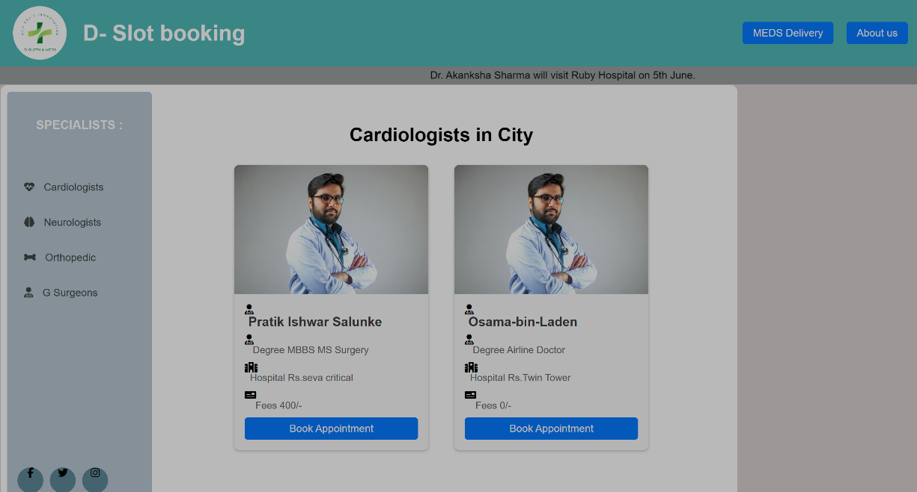

**Database Design**

Database Name: sydb

Table Name: - docform

Table Name: - registration

**Data Dictionary :**

**Code :** [**GitHub**](https://github.com/H4tarakh/Doctor-Appointment-System)

**5. Software and Hardware Specifications**

|  |  |
| --- | --- |
| **Software Requirement** | |
| Operating System | Microsoft windows |
| **Software Technology: -** | |
| Front –End Software | WAMP Server, HTML, CSS, JavaScript |
| Back-End Software | PHP, MySQL |
| **Hardware Requirement** | |
| Processer: | Intel core i5 2GHZ |
| RAM: | 4GB or more |
| Monitor: | LCD monitor |
| Keyboard: | Normal keyboard |
| Mouse: | Compatible mouse |

**6. Output and Report Testing**

**6.1 Test Plan**

Objective: To ensure the functionalities of the doctor appointment system are working as expected.

Steps:

Test user registration process for patients and doctors.

Test doctor selection and appointment booking process.

Test medicine purchase functionality.

Test doctor login and appointment viewing functionality.

Test data validation for all input fields.

Test system performance under different loads.

Test system security against common vulnerabilities.

**6.2 Black Box Testing/Data validations Test cases**

Test Cases:

Validate that all required fields in the registration form are filled.

Validate that the email entered is in the correct format.

Validate that the password meets the required complexity criteria.

Validate that appointment slots are available for booking.

Validate that the medicine quantity selected is within the available stock.

Validate that the login credentials entered are correct.

**6.3 White Box Testing/functional validations Test cases and results**

Test Cases:

Verify that registered patients can log in successfully.

Verify that registered doctors can log in successfully.

Verify that patients can book appointments with available doctors.

Verify that doctors can view their appointments for the current day.

Verify that patients can purchase medicines successfully.

Results: All test cases passed successfully without any errors.

**7. Conclusion and Recommendation**

**Conclusion:** The doctor appointment system has been successfully developed and tested, providing a convenient platform for patients and doctors to connect.

**Recommendation:** Regular maintenance and updates should be performed to ensure the system's smooth operation and security.

**8. Future Scope**

Integration with Telemedicine: Implement video consultation features for remote appointments.

Enhanced Appointment Management: Introduce features for rescheduling and cancelling appointments.

Improved Medicine Inventory Management: Implement real-time stock updates and alerts for low inventory.

**9. Bibliography and References**

[PHP Manual](https://www.php.net/manual/en/index.php)

[WAMP Server Documentation](https://www.wampserver.com/en/category/documentation-en/)

[Apache HTTP Server Documentation](https://httpd.apache.org/docs/)

[HTML5 Documentation](https://www.w3.org/TR/2011/WD-html5-20110405/)

[Code With Harry](https://www.youtube.com/watch?v=1SnPKhCdlsU)

[W3 School](https://www.w3schools.com/js/)

[Medibuddy](https://www.medibuddy.in/)

[Apnacollege](https://www.youtube.com/@ApnaCollegeOfficial)